Task 3:
Extend the code to remember the previous mode and avoid repeating identical control commands. Keep the existing temperature thresholds and occupancy priority. Add internal storage for the previous target mode, returning both the target and whether a command should be sent. Run repeated percepts, both exact boundaries, a mode transition and an empty-room case. Record previous mode, percept, target and command/no-command outcome.

Explanation:

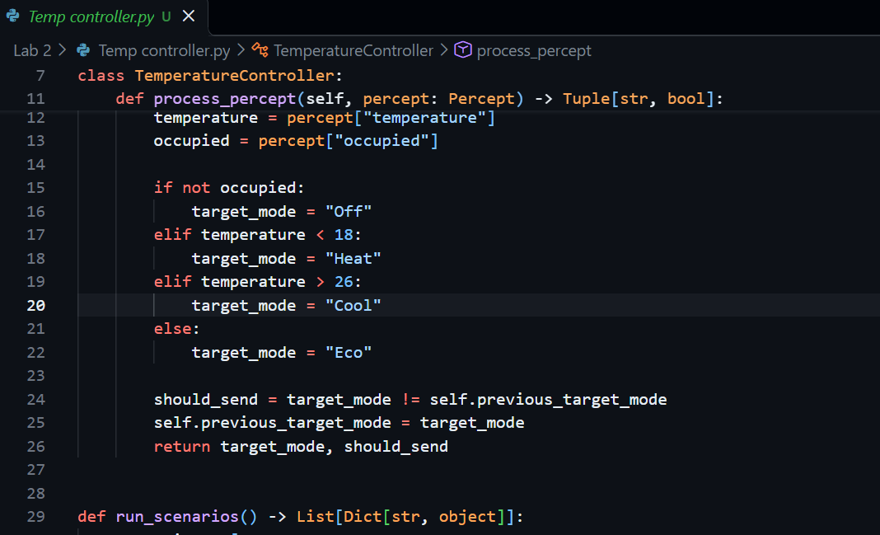

Scenario | Previous Mode | Temperature | Target | Outcome
Cold room | None | 17 | Heat | Command: Heat
Repeated cold | Heat | 17 | Heat | No command
Lower boundary | Heat | 18 | Eco | Command: Eco
Upper boundary | Eco | 26 | Eco | No command
Mode transition | Eco | 28 | Cool | Command: Cool
Empty room | Cool | 30 | Off | Command: Off

Explanation
- previous_target_mode stores the last mode.
- should_send checks if the new mode is different.
- If the mode is same, no command is sent.
- If the mode changes, a new command is sent.
- If the room is empty, the target mode is always Off.

